Student Chen Jiaxin (Batch 2021/09, Chinese)
Learning physics has never been an easy task. Fortunately, I have met many great teachers and companions on the road of learning physics.
The lecturers in the Department of Physics are very responsible and friendly. Every question after class will be answered in a timely and patient manner. In daily lectures, our lecturers immerse themselves in the beauty of physics or mathematics in delivering physics knowledge to us. The excitement and devotion make us feel deeply connected to physics. In my sophomore year, I also joined the physics society and met many friends from the physics department. Dining together from time to time, we chat and discuss our future directions, have occasional meetings to plan physics-related project activities and putting them into practice. The activities outside of studies are fun and fulfilling.
With the advancement of my studies, I have realized that learning should not be limited to textbook knowledge. I am grateful to the assignments at the end of some courses that provides us an opportunity to study independently. While the process of writing a short project report is challenging, the process of self-selecting a topic of interest and exploring it is enjoyable. With each brainstorming session, the coming together of the report makes me feel accomplished. Most importantly, the independent study is just a catalyst for us to explore unknown areas, driven by our own initiative, to satisfy our curiosity.
The Laboratory class in my sophomore year was my first real contact with physical experiments after the epidemic. From the experiments, I have since found that there is always a big gap between theory and reality. There were various unexpected challenges in real experiments, and we had to improvise and modify the experimental method. This had a big impact on us, and it was the first time that we really felt the difficulty of designing an experiment. The self-designed experiment based on arduino is a field that we have never set foot in before. This is not something that can be summed up in textbooks, so we had to take the initiative to self-learn a lot of additional skills, such as simple programming and circuit connection of arduino, analysis and processing of experimental data, and many others. The lecturer for this class is not only imparting knowledge, but training us to confront and solve problems, sharing of each other’s experiences, and often enlightening us.
What impressed me the most was the poster presentation at the end of the semester. The lecturer asked us to summarize the experimental results of this semester into a poster, and invited many other lecturers and students from our Physics programme to observe and guide us. We practiced giving presentations on our experimental works with this opportunity. At the same time, we have benefited a lot from new perspectives from the students and the professors. The professors behave as both our teachers and friends, they are generous in imparting knowledge and experience, and also sincerely ask questions about areas that they do not understand, which makes the learning process even more wholesome.
Student Leong Jing Tian (Batch 2021/04, Malaysian)
Most of our lecturers are very friendly, especially Assoc. Prof. Lim Yen Kheng and Prof. Tomasz Paterek. Prof. Lim will explain the concepts in detail and clearly. He will also provide step-by-step derivations and notes. At the same time, Prof. Tomasz will give some exercise questions on the spot and point out your error directly during class time.
Moreover, there were also some memorable experiences during the lab session. I joined the lab session with our seniors during the first physical lab session after the pandemic because we have only two students in our intake. Fortunately, I met my kind teammates, who led me to complete the experiment. Secondly, I joined the lab session with our juniors for my second lab session during the last semester (2022/09). Also, this semester, we had our first experience with poster presentations. It was enjoyable and memorable.
I work as a multimedia in the XMUM Physics Society. We conducted our first event, the new student orientation, for two days last September. My job scope is to take photos and edit videos during the event, also managing the social media account of our society. It was really fun and, of course, exhausting, but it is good to make a bonding between seniors and juniors.
Student Yang Ziou (Batch 2020/09, Chinese)
Welcome to Physics department in Xiamen University Malaysia! My name is Yang Ziou, I’m an undergraduate student from Physics Department in 2020. Because I am very interested in the theory of everything, I choose to major in physics.
So far, I have been studying in the physics department in Xiamen University Malaysia for nearly three years. My first and second years are in the form of online courses due to the COVID-19. Although I could not communicate with my teachers and classmates face to face, through online communications, I learned about thermodynamics through the teaching of Prof. Ong, the charm of electromagnetic by Prof. Tomasz, the knowledge about optics by Prof. Kelvin, and interesting contents of quantum by Prof. Lim. I could feel the enthusiasm of teachers in physics department and the unity of the students in the department. In my junior year, I came to Malaysia to take physical courses.
There are many interesting experimental courses in the physics department. Although I did not experience physical experiments when I was a freshman and sophomore, online experiments also gave me a very happy experience. Through the online laboratory link given by Prof. Chung, Prof. Kelvin and Prof. Siti, our physics students conducted experimental explorations with each other, such as setting quantitative and variable parameters and observing interesting changes in various experiments.
There will certainly be difficulties on the way of learning, and the teachers of the Physics department welcome us to ask questions. For the online teaching, if we have questions, teachers would provide us detailed answers to each question through teams. For the physical teaching, if I have a big doubt, teachers would take the time to invite me to their office to talk to me face to face so that gave me more detailed explanations.
One of my most memorable learning experiences was doing research with Prof. Lim Yen Kheng with the content of Hayward Space and time. Because I want to develop on the road of astronomy, I really wanted to do research together with the kind Prof. Lim. This research lasted throughout my sophomore year. Prof. Lim first gave me some books to read to understand the conceptual basis of the theory of relativity. Then he patiently, step by step, guided me on how to write my paper, how to conduct the next step of research, explore the physics of solving Einstein's equations in Hayward space-time, observe the trajectory of charged particles and so on. Here, I would like to thank Prof. Lim, who has given me great help, made me more interested in theoretical physics, and strengthened my confidence to take the road of astronomy.
A few days before the physical courses of my junior year were about to begin, the entire physics department held a welcoming ceremony for the freshmen of the 22nd physics department. Prof. Ong, Head of the Department of Physics, Assistant Professor Lim Yen Kheng and Chuang Fei Fang gave us a wonderful speech, let us understand physics and the future of physics. During the two-day ceremony, students from the physics department played a lot of interactive games together in the welcome, and I deeply felt the unity and enthusiasm of the physics department.
The department of Physics in Xiamen Malaysia is a friendly group full of physics wisdom and mysteries. Welcome to know and join the family of the Department of Physics! I hope you can have an unforgettable and wonderful university experience.

Student Exchange Program

The Department of Physics of XMUM has signed a Memorandum of Understanding (MoU) with the Faculty of Mathematics, Physics and Informatics in University of Gdansk, Poland, to offer a Research Internship Student Exchange Program for the students of both university departments.

Xiamen University Malaysia has active and growing collaborations with University of Gdańsk in Poland. The two institutions have signed memorial on student exchange for the purpose of conducting research abroad. University of Gdańsk is world famous for their discoveries in quantum information and hosts International Center for Theory of Quantum Technologies. Prof. Tomasz Paterek collaborates with the Center and the Institute of Theoretical Physics and Astrophysics on quantum correlations, Bell inequalities and foundations of physics as well as on quantum optics.

The purpose of this program is to forge a close academic and research collaboration with University of Gdansk, which is one of the top universities in Quantum Physics and Technology. The program may become one of the first academic and research collaboration for XMUM at the undergraduate level , and would definitely raise the status, international standing and attractiveness of the XMUM BSc (Hons.) Physics programme.

Vice president dr Zhang Ying, Professor Ong Chong Kim and Dr. Kelvin Ooi visited TOP Gloves on 29 November 2022

Physics Lab

This is a guided design lab module to stimulate students’ creativity in designing experiments and/or instruments for the investigation of physics phenomena. Students will be divided into groups. They work as a team to solve problems. Each of the groups needs to design an experiment about mechanics or thermodynamics(PHY206), incorporating Arduino as the main measurement tool. Each group will be allocated a small budget to buy some accessories they need in setting up their experiment. There is no examination in this course. 100% of the course mark is from the continuous assessments. The continuous assessments include weekly discussions, a final report, and a poster presentation.

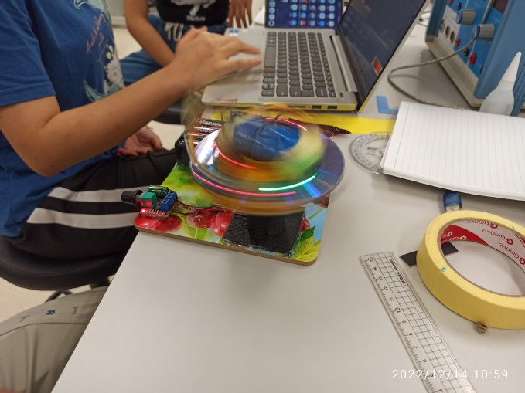

The centripetal acceleration on a rotating disk is investigated.

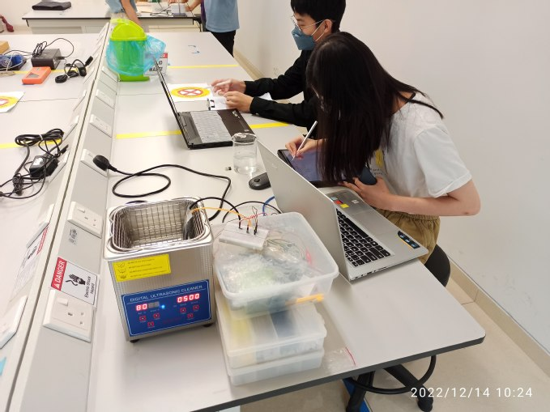

Using Arduino to measure the resistance at various temperatures.

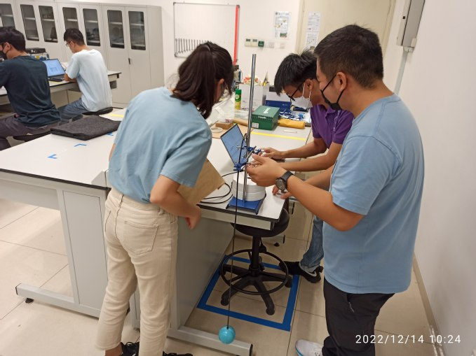

Investigation of the motion of the pendulum with an accelerometer.

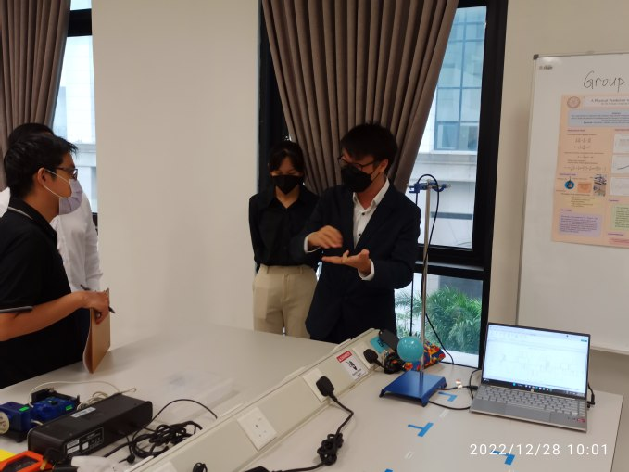

The student is explaining their design to the judge during the poster presentation.

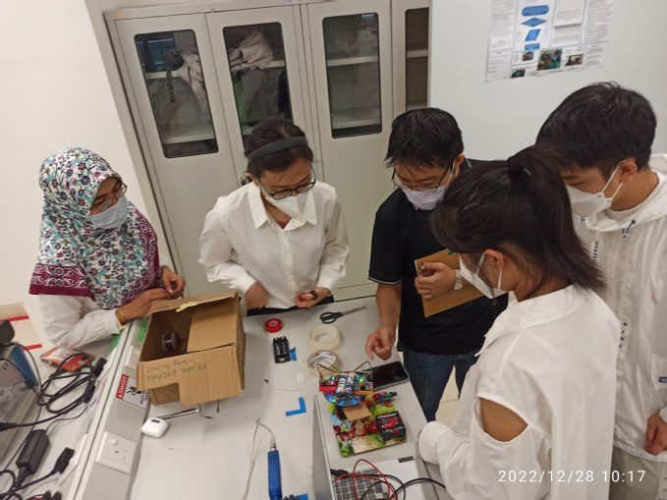

Students need to answer the questions asked by the judge.

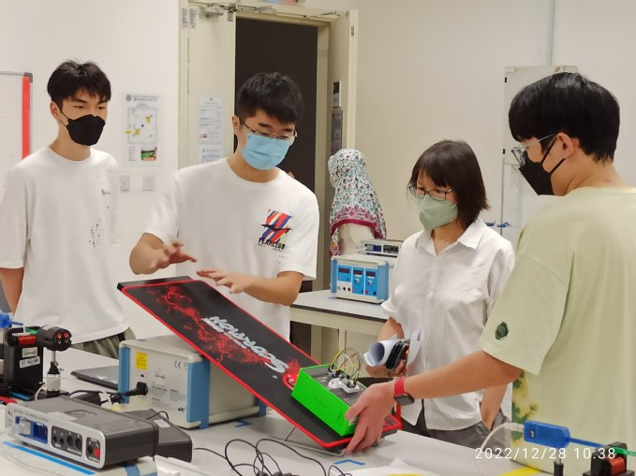

Students demonstrate their experiment to the judge.

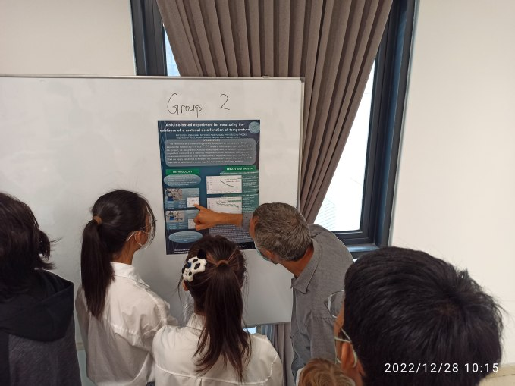

The students are listening to the comments given by the judge.

The Center for Postgraduate Studies and Research congratulates Yang Ziou and Associate Professor Dr. Lim Yen Kheng from XMUM Department of Physics for the recent article published in Physical Review D, a Q1 journal with a latest impact factor of 5.407.
Entitled “Structure of test magnetic fields and charged particle motion in the Hayward spacetime”,the study is about the nature of electromagnetic interactions in a non-singular spacetime first discovered by Hayward in 2006. The exterior of the spacetime approximates the well-known Schwarzschild solution. Hence, it may be possible that the Hayward spacetime can mimic astrophysical black holes.
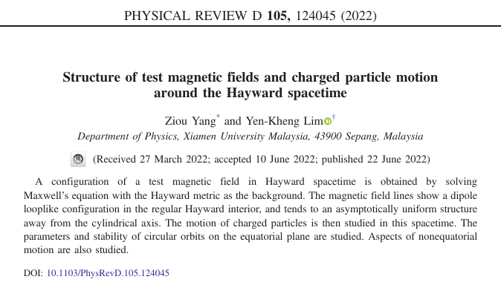
The article can be accessed at https://journals.aps.org/prd/abstract/10.1103/PhysRevD.105.124045.
The Arxiv preprint can be found at https://arxiv.org/abs/2203.12124v2
Solving Maxwell’s equation on Hayward’s spacetime yields interesting magnetic field configurations, such as the one shown in Figure 1. This figure shows the magnetic field configuration of the horizon-less Hayward spacetime. The two blue diamonds in the figure indicate points of zero magnetic field, and a charged particle can be trapped in a region around these two points.
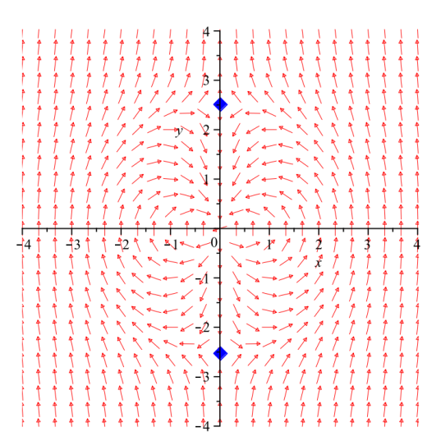
Figure 1
Charged particles with higher velocity makes their characteristic cyclotron loops encircling the magnetic field lines, which is the typical behavior of any charged particle interacting with a magnetic field. However, the dipole configuration of the magnetic field results in particle orbits shaped like onions, or pumpkins, as shown in Figure 2.
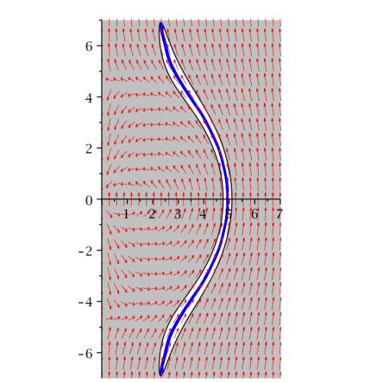
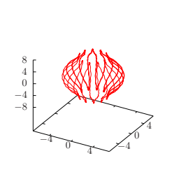
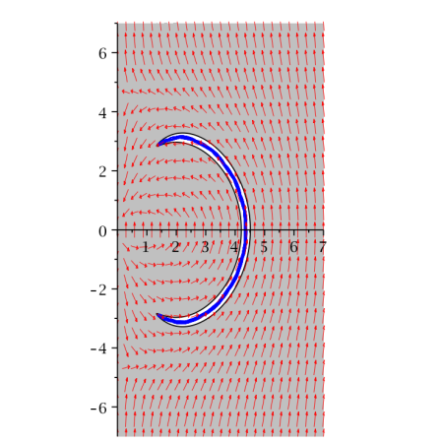
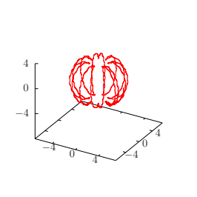
Figure 2: The left panels of the figure depict the magnetic field (red arrows) and the particle motion (blue curve) in cylindrical coordinates where the azimuthal direction is suppressed. The right panels depict the corresponding orbits in Cartesian-like coordinates.
Authors information
Picture | Introduction/Profile
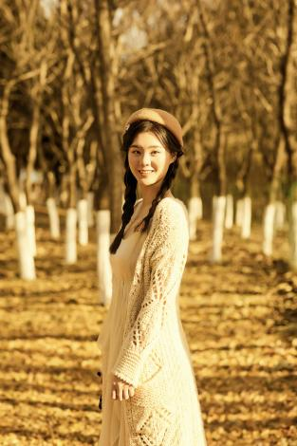 | Yang Ziou is a sophomore undergraduate studying at the Physics department of Xiamen University Malaysia. She is interested in black holes, astrochemistry, and astronomical detection.
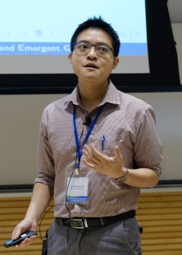 | Dr. Yen-Kheng Lim is an Associate Professor of Physics at Xiamen University Malaysia. He received his PhD in 2015 from the National University of Singapore, where he has worked for several years as an instructor. His research interests include black holes, general relativity, and gravitational systems in the context of holography and quantum gravity.

Visit by distinguishing industrial advisor Mr. Philip Bernard Saram, Senior Vice President, Global HDD Operations, Western Digital 31 Oct 2022. Our deepest appreciation to our distinguishing industrial advisor for the visit and sharing on Innovation, The Innovator & 4IR adopt gold.

Faculty Visit

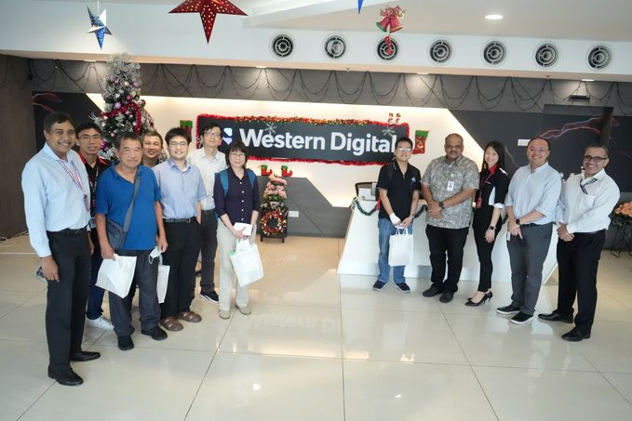

Visit of faculty members to Western Digital KL Center of Excellence, 1 December 2022. Thank you for hosting us and also a wonderful discussion session. We look forward to further collaboration.

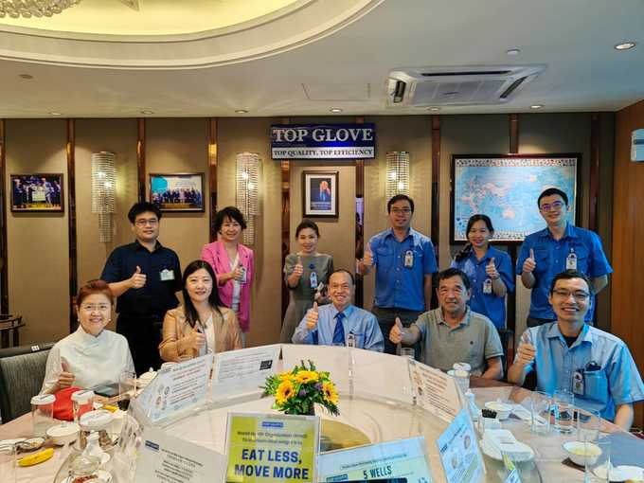

Vice president dr Zhang Ying, Professor Ong Chong Kim and Dr. Kelvin Ooi visited TOP Gloves on 29 November 2022
Observation of the partial solar eclipse on 20th April 2023
On the 20th of April 2023, a partial solar eclipse occurred over Malaysia. The students and staff from the physics department of XMUM has set up two telescopes to observe the event. The weather over Sepang at that time was cloudy and it hindered a clean observation.
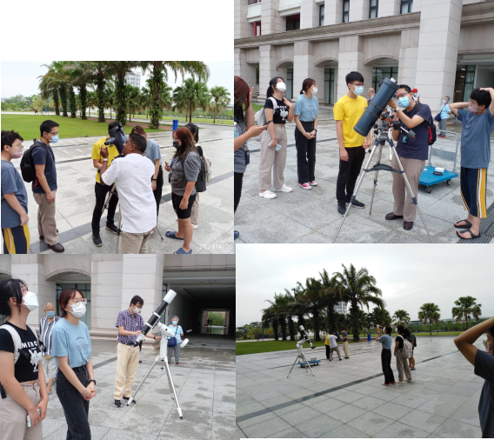

Physics Students Participate in Inaugural Research Internship Student Exchange Program in University of Gdańsk, Poland
Two students from the Bachelor of Science in Physics (Honours) program – Mr. Ng Khai Shuen and Mr. Ong Ming Khai – have participated in the inaugural Research Internship Student Exchange Program in University of Gdańsk in Poland for the April 2023 semester.In January 2023, the Department of Physics of XMUM has initiated a collaboration with the Faculty of Mathematics, Physics and Informatics in University of Gdańsk, Poland, to offer a Research Internship Student Exchange Program for the students from both university departments. A Memorandum of Understanding (MoU) was signed between the Vice President of XMUM, Assoc. Prof. Dr. Zhang Ying, with the Rector of University of Gdańsk, Professor Piotr Stepnowski, to formalize this collaboration.This program is one of the first academic and research collaboration for XMUM at the undergraduate level. University of Gdańsk is world famous for their discoveries in quantum information and hosts the International Center for Theory of Quantum Technologies. Prof. Tomasz Paterek collaborates with the Center and the Institute of Theoretical Physics and Astrophysics on quantum correlations, Bell inequalities and foundations of physics as well as on quantum optics.The two students who are currently undergoing their research internship in University of Gdańsk have shared their thoughts with us as below:Mr. Ng Khai Shuen (PHY Batch 2020/09)
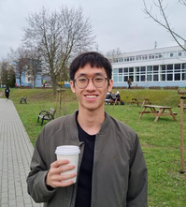
Khai Shuen in the University of Gdańsk campus
I'm currently working on the topic of general relativity minimally coupled to massless scalar fields. The goal of this project is to look for more classes of solutions in spacetimes where gravity sometimes repulses instead of attracts (i.e., has an opposite effect), where it was shown to be the case for one particular solution only.I had a very good opportunity to gain exposure; not just to different cultures and new people, but to see how different people approach Physics outside of a local setting, and to learn from them. One can argue that Physics is still Physics across different languages and cultures, but I think that everyone has very different sensibilities and “feels” when it comes to approaching math or physics. These differences, which essentially constitute one’s way of thinking, influence the formation of one’s ideas; and seeing as much of that as we can is imperative, especially as a budding young scientist (or whatever you plan to do in the future). Broaden your horizons and learn from as many sources as you can!
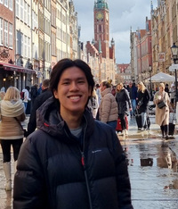
Ming Khai in the City of Gdańsk
I will be studying the relationship between solar activity and climate indicators, which takes historical records of sunspot numbers, climate data, and tree ring records into account to determine the degree of influence that variations in the Sun have on Earth's climate. Python programming will be used to help automate the process of primary component analysis of the large amounts of data, and apply statistical studies to the results.
The internship program has allowed me to get a real feel of academic research, and I am very grateful to have the opportunity to conduct this research in a new environment. I’m definitely excited to be here, despite the cold temperatures!
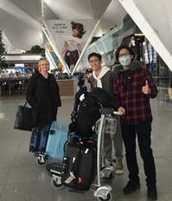
Khai Shuen and Ming Khai greeted by Ms. Gosia on arrival at the Gdańsk airport
For more information about the Physics Research Internship Student Exchange Programme, please visit https://www.xmu.edu.my/2023/0308/c20772a469579/page.htm or contact Prof. Tomasz Paterek at paterek.tomasz@xmu.edu.my

